**RIPHAH INTERNATIONAL UNIVERSITY, ISLAMABAD**



**Lab # 2**

**Bachelors of Computer Science – 6th Semester**

**Subject: Operating System**

**Submitted to: Ms. Kausar**

**Submitted by: Nimra Ashfaq-40852**

**Date of Submission: 02- Sep -2024**

**TASK:1**

* Start by creating two directories named OS_Course and OS_Lab.

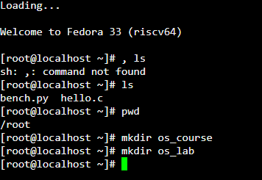

* After creating these directories, switch to the OS_Lab directory.



* Within OS_Lab, create three more directories named **LAB_Class_Task, LAB_Activities, and Lab_Practice**.

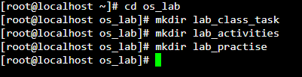

* Go into the **Lab_Practice** directory and create a file named example.cpp.

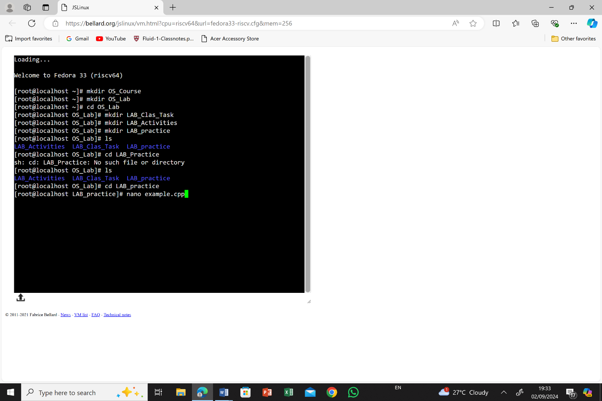

* This file should be empty and will be used for practice later.

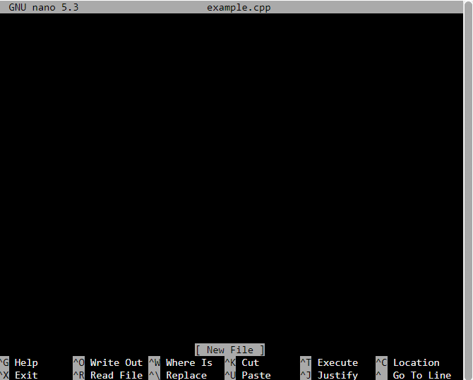

* Move back to your home directory.

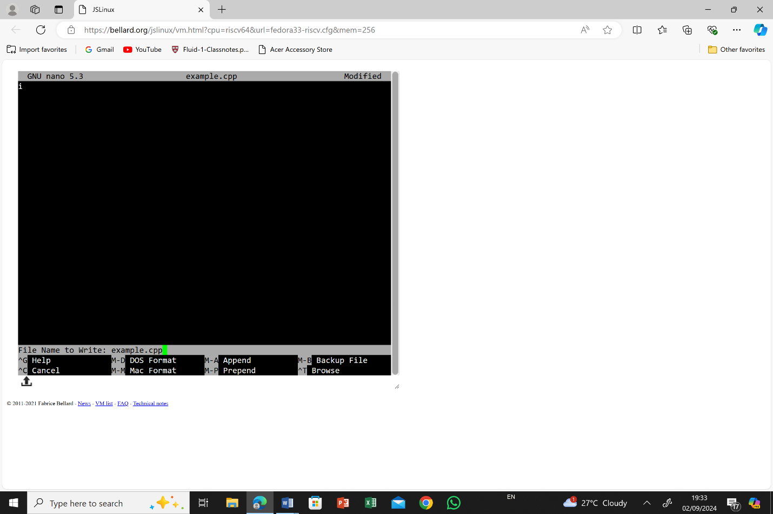

**TASK: 2**

**Absolute Path:**

* In Linux, an absolute path always starts with a /, which represents the root directory.
* It gives the complete location of a file or directory from the root.
* **Example:**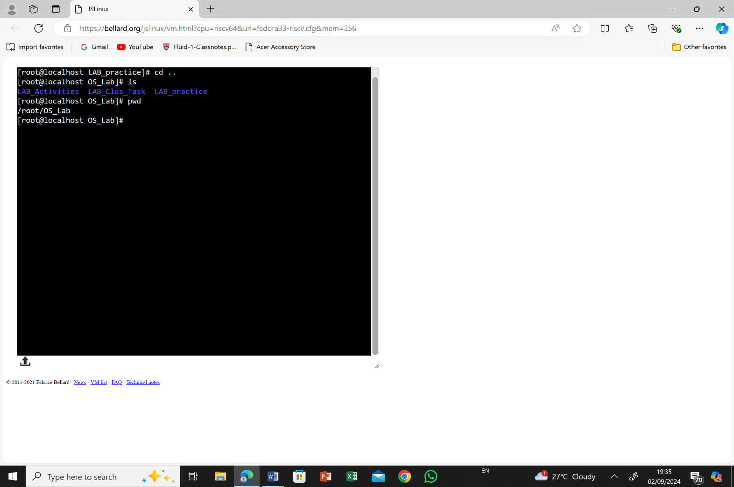

**Relative Path:**

* The concept of relative paths is all about where you are currently in the directory structure and how you move from there.. It does not start from the root directory but rather from the directory you are currently working in.
* **Example:**
  + 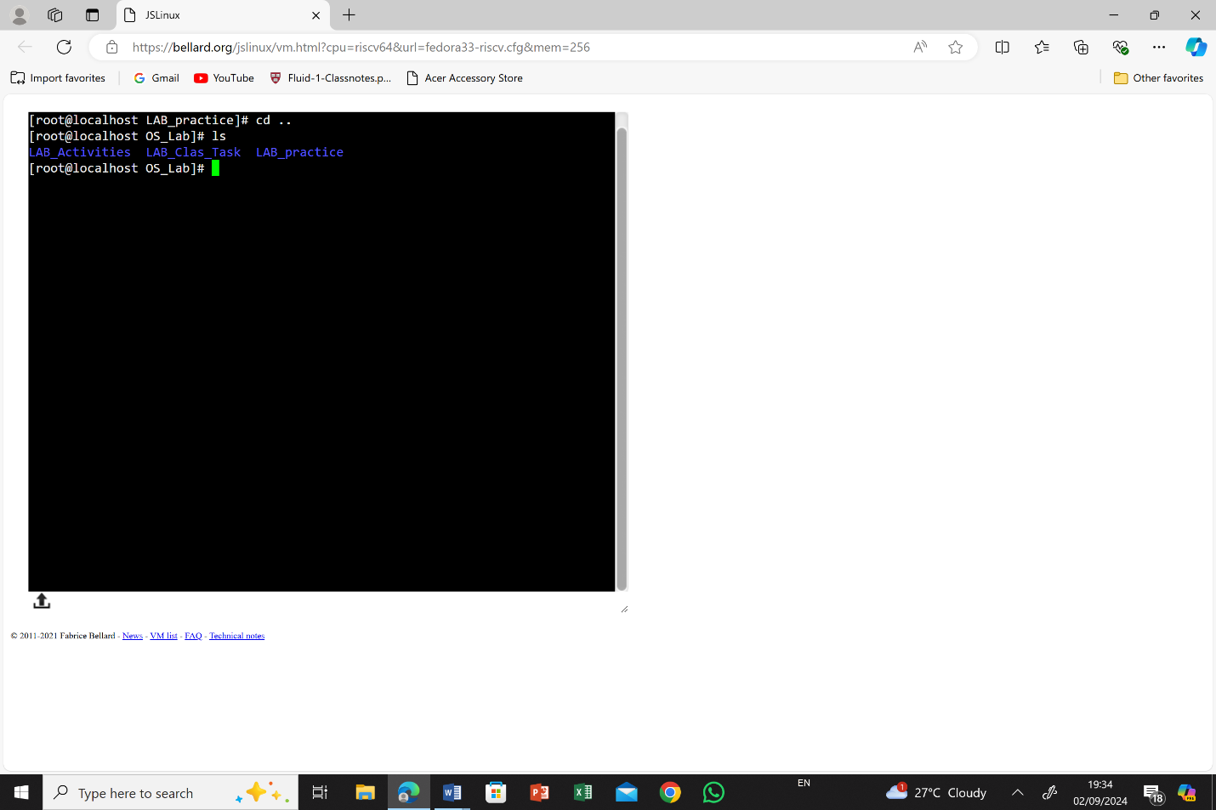If you are in the lab_practice directory and want to access a file in lab_activities:

Current Directory is **lab_practice**.To access the **lab_activities** directory from **lab_practice** using a **relative path**, you would move up one level to the parent directory and then down into the **lab_activities** directory

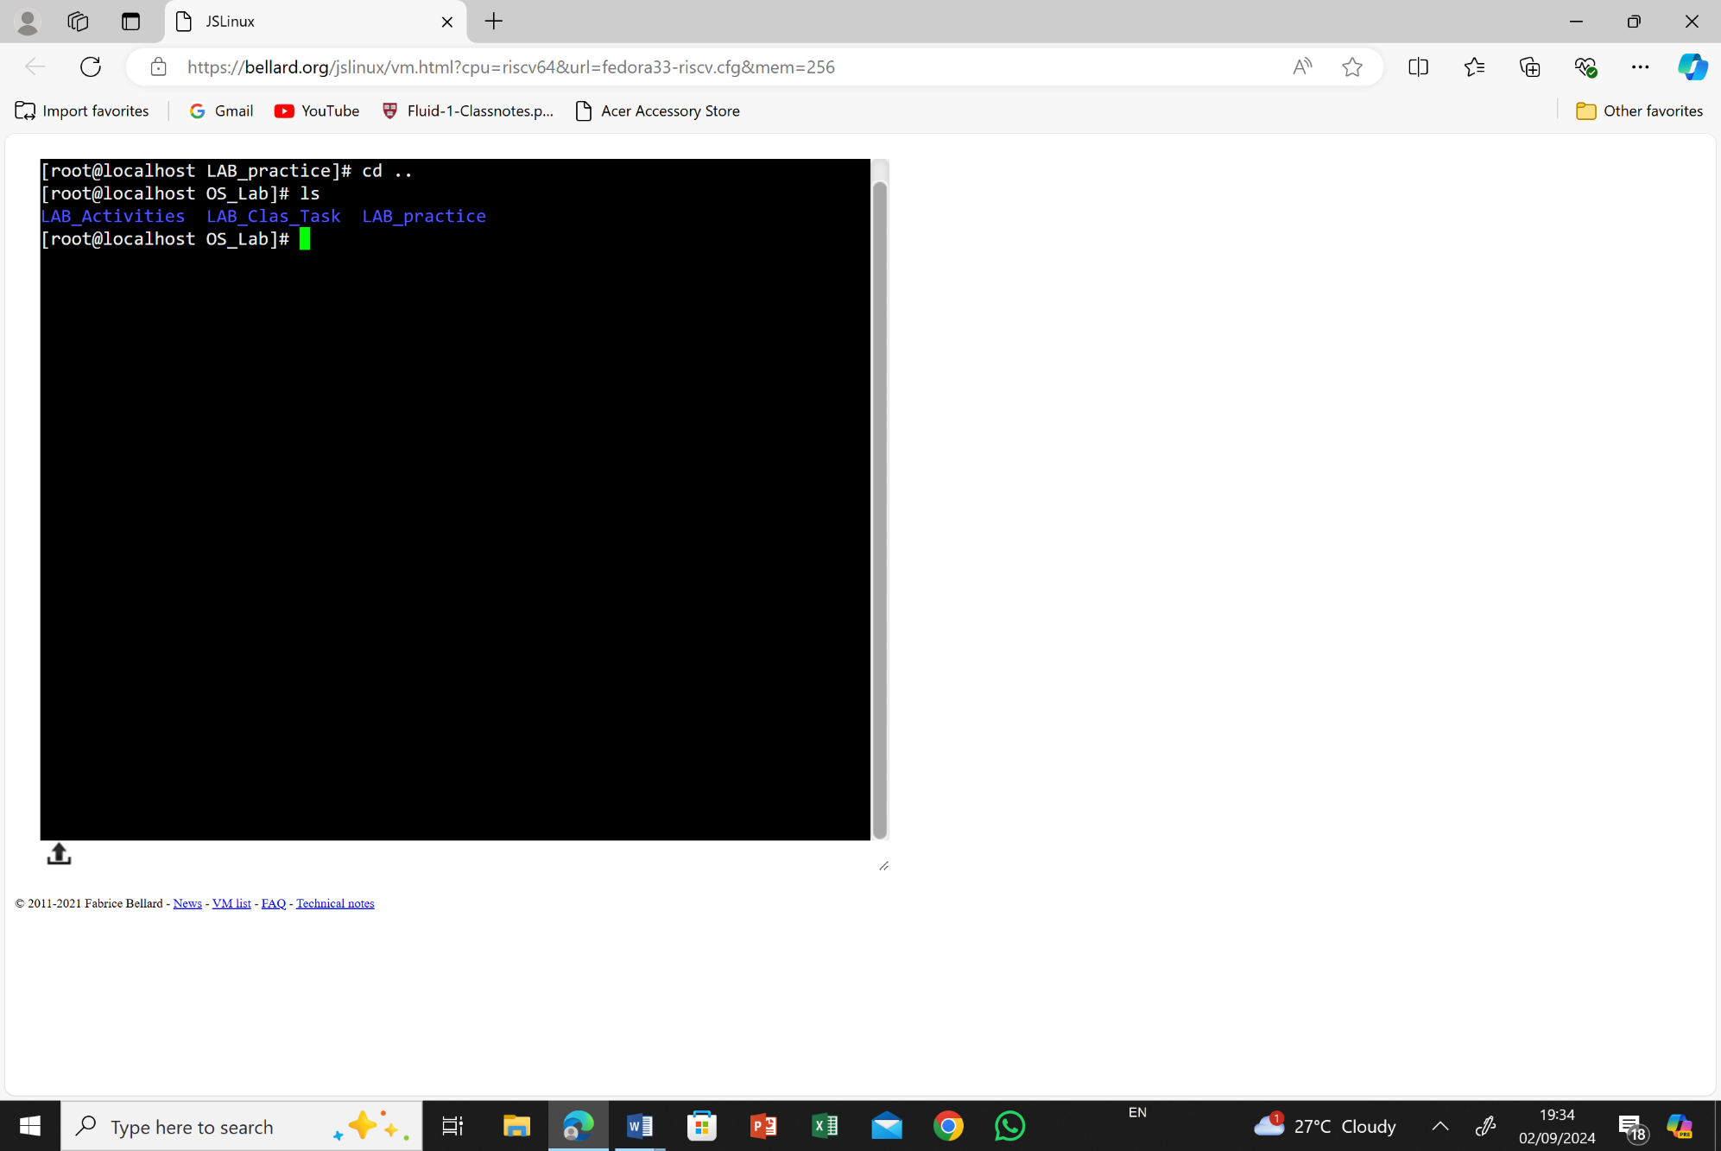

**TASK: 3**

When you press and hold the power button to turn off your computer, it typically goes through a "hard shutdown." When you do a hard shutdown, the computer turns off instantly without properly closing programs. When you turn it back on, it quickly checks the hardware power on self-test (POST), uses a fast startup feature (like Fast Boot or Hybrid Sleep) to load a saved system state from the disk, and then loads the operating system and drivers. This process skips some usual steps, making the startup faster and smoother, bringing you quickly to the login or desktop screen.